For Advisors – Advising #1 Meeting Flow
November 11, 2014
Portfolio
- Ensure it is complete and neat (3-hole punch) – see checklist
- Distribute binder dividers – see supply closet
- Review/reinforce purpose and how to use the portfolio (captures academic progress, documents USP participation w/reflections, etc.)
- Discuss tutoring, classes
Report Card
- Review previous year grades – see Advising binder next to SHW’s desk
- Review current grades
  - Were they surprised (pleasantly or not)?
  - For each grade, prompt them to discuss the class – how is the grade determined (classwork, homework, quizzes, tests, projects, etc.)
  - Review tardy and absent data
  - Discuss metacognition, agency, USP support
- Make a copy and return the original
Winter/Spring Placement
- If the student has 2 or more “Cs” (or worse) explain the Winter Achievement Academy and distribute contract – see server Fall 2014 > Advising
- If in good standing, discuss class, elective tutoring, ICA options
- Excelling 10th and 11th graders – discuss UCourse options
Goal Setting and Advising Self-Assessment Worksheet
- Complete worksheet together and discuss – see server Fall 2014 > Advising
- When complete, add to portfolio
Reminders
All students – winter intentions due ASAP; Thanksgiving potluck 11/19
Enrollment confirmation needed by 1/9/15

Urban Scholars – Fall 2014 Advising
Student Checklist
My Portfolio Includes:
_____ Placement Agreement
_____ Tutoring Contract
_____ Tutor Log
_____ Bi-weekly progress report(s)
_____ Report Card
_____ Graded Work (variety of grades)

_____ My advisor and I have reviewed last year’s and this quarter’s grades
_____ My advisor and I have discussed my participation this year and next semester
_____ I must attend the Winter Achievement Academy
_____ I will be in tutoring for the Winter/Spring Semester
______ Elective
______ Mandatory
_____ I will be in a class for the Winter/Spring Semester
_____ I will be requesting a program leave and will return the Winter 2015 Program Leave form

_____ I am interested in one of the following opportunities
_____ Poetry Out Loud
_____ Engineering Club – Bridge Building Competition

_____ I have completed and discussed the Self-Assessment Worksheet

_____ I have added to my portfolio the following:
    - Quarter 1 grades
    - Self-Assessment Worksheet
    - Binder Dividers
    - This Checklist
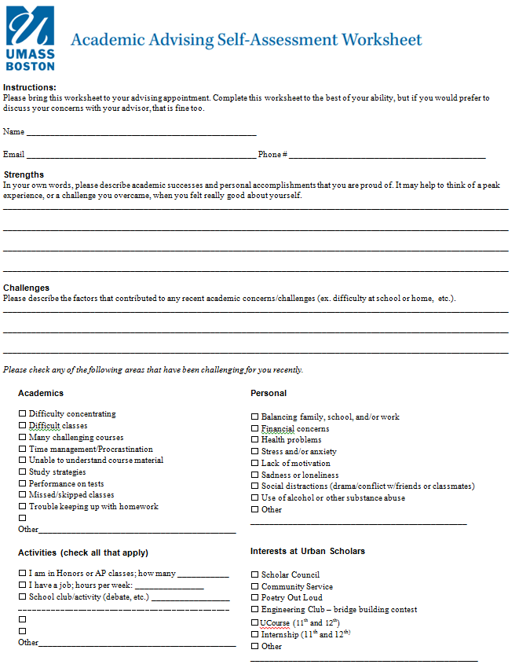

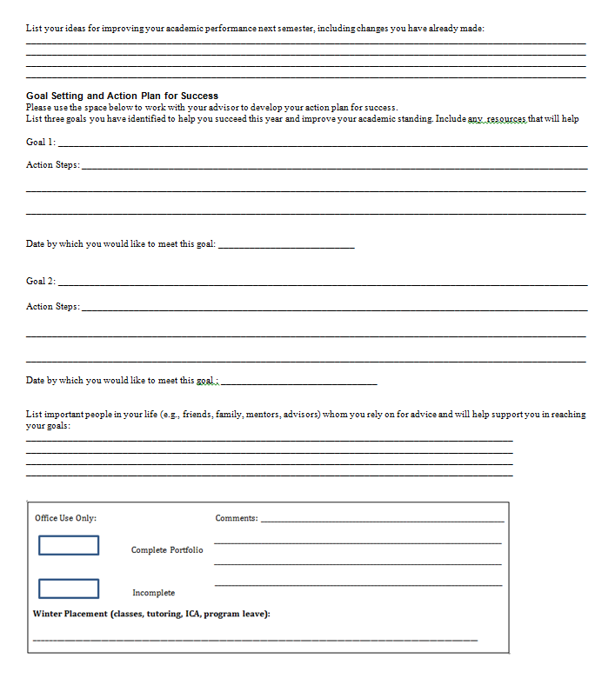

Placement Agreement – Winter Achievement Academy
Because of your current GPA of _____________, you are required to attend the Winter Achievement Academy (WAA) at Urban Scholars. This is a mandatory program for students below a 3.0 GPA. Should you choose not to participate, you risk being replaced and must reapply for admission.
- WAA takes place afterschool from 1/5/2015 – 1/23/2015.

- Each student will work closely with a tutor to focus on their most challenging subjects and prepare for mid-term exams.

- The commitment is 4 hours each week, visiting twice (or more) each week.

- Program leave is not allowed for WAA.

- Students will create and maintain a specific schedule for WAA.

- Students will receive a transportation stipend of $5/week for WAA.
Your WAA schedule will be
_________ Monday from ________________to______________
_________ Tuesday from _________________to_____________
__________ Wednesday from _____________to_________________
_________ Thursday from _____________to_________________
_________ Friday from ________________to______________
By signing below, I acknowledge that I understand the requirements above and will participate.
_________________________________________________________ ____________________
Student Date
_________________________________________________________ ___________________
Parent/Guardian Date

Winter 2015 Program Leave Contract
The Urban Scholars Program encourages students to participate in numerous enrichment and extra-curricular activities. We provide many of these including after-school classes, community service opportunities, outdoor recreation, college tours, field trips, and more.
However, students frequently desire to participate in other programs that help prepare them for college.
IMPORTANT: Students are eligible for a leave from the program ONLY IF they are doing well in school. This means they must have a 3.0 GPA and no grade lower than a “C”. If a student chooses to neglect this rule, they must reapply for admission to the program at a later date.
REMEMBER: All students MUST attend their winter advising meeting between 2/23/15 and 03/05/2015.
This document does 2 things:
1. Serves as a “contract of understanding” between the student, parent, and program.
2. Guarantees the student may continue participation in the Urban Scholars Program during and after their leave.
If you agree to the above, please sign and return to the Urban Scholars office

REASON for program leave: ___________________________________________________________________________

Length of program leave – include exact dates:
__________________________________________________________________________________________________

____________________________________________________ __________________
Student Date
____________________________________________________ __________________
Parent/Guardian Date
____________________________________________________ __________________
School/Program Official Date
Advising #1 Debrief and Data First-Look
December 22, 2014
Objectives
Debrief overall experience and operations
Brainstorm general topics for winter workshops
Identify at-risk and high-achievers
Collect data re: winter placements, poetry out loud, engineering, etc.

Check-in Topics:
Sign-up/registration Student follow-through Timing and content
Flow and general approach Organizing/distributing materials Self-assessment use
Portfolio quality Nature of action plans Student/advisor experience
Feedback/Suggestions?

Winter/Spring/Summer Workshop Ideas
Content Areas
Skill/Habits of Mind Areas

Students at-risk (below 3.0 or social-emotional)
11th graders – final warnings issued?

Data
WAA numbers
GPA in database/spreadsheet – Quarterly?

Required:
Daryl P (11)
Raulina (11)
Anilson
Rashawn
Cassandre
Godson, Lauds (11)
Gabby P
Cristina Neto (11)
Yakub (11)
Christelle
Adilse
Iverson
Ayanne
Recommended:
Tresvonni
Cindy
Carlene
Rashane

