**Urban Scholars Program**

**Student/Family Handbook**

**Academic Year 2014-2015**

UMBformalblue

**Program Mission**

The mission of the Urban Scholars Program is to work collaboratively with the Boston Public Schools to identify and develop Boston’s gifted and talented urban youth (ages 11-19), especially those who come from low-income families and/or first generation in their families to attend college. The Urban Scholars Program provides students with the skills and attitudes necessary to achieve their full potential through a structured sequence of after-school and summer academic courses and enrichment activities designed to build a strong repertoire of basic and higher level skills, task commitment and self-motivation needed for a successful college experience.

**Vision**

We prepare students for college by

* + Ensuring their academic records are strong and they are challenged to explore a variety of majors, careers, and internship opportunities
  + Ensuring they have college-ready skills and take the necessary steps to apply to college and secure financial assistance
  + Ensuring they are developing into thoughtful, well-rounded, and growth-oriented individuals

**Core Staff**

|  |  |  |
| --- | --- | --- |
| Main Office | (617)-287-5830 | [urbanscholars@umb.edu](mailto:urbanscholars@umb.edu) |
| Stephanie Hicks-Williams, Office Manager | (617)-287-5830 | [stephanie.williams@umb.edu](mailto:stephanie.williams@umb.edu) |
| Kevin Dean, Asst. Director | (617)-287-5827 | [kevin.dean@umb.edu](mailto:kevin.dean@umb.edu) |
| Suamy Ventura, Program Assistant | (617)-287-5836 | [suamy.ventura@umb.edu](mailto:suamy.ventura@umb.edu) |
| Akunna Rosser, College Counselor/Recruiter | (617)-287-5831 | [akunna.rosser@umb.edu](mailto:akunna.rosser@umb.edu) |
| David Lemmel, Director | (617)-287-5665 | [david.lemmel@umb.edu](mailto:david.lemmel@umb.edu) |

**Urban Scholars Student Expectations**

As a UMB youth program, the Urban Scholars Program abides by the university’s code of conduct for K-12 programs. In addition, as a learning community, we commit to living up to high expectations in order to support one another’s growth and ensure safety, engagement, and enjoyment.

* **High Expectations = the BEST versions of ourselves**
* **Core Expectations:**
  + **Respect**
  + **Community**
  + **Excellence**
  + **Commitment and Engagement**
  + **Achieving – Thriving - Connecting**

**An Urban Scholar is…**

* **Always on-time, ready to learn**
* **Committed to college attendance and graduation**
* **Engaged and participating**
* **Respectful; helpful; concerned for others and their well-being**
* **Positive, optimistic, and a team-player**
* **A hard worker and consistent, clear communicator**
* **Focused on success and driven to achieve**
* **Someone who asks questions, seeks and provides assistance**
* **Seeks out opportunities, takes on challenges, and strives to improve**

**Uniting Our Work: A Framework for Success**

Each component of our program – academics, tutoring, enrichment, advisory, and portfolio - is united under the A-C-T Framework. This establishes the skills and experiences we feel necessary for success in school, college, and life. Our goal for each scholar is for him/her to experience significant growth in each area and have the opportunity to engage in each skill in a variety of ways over time.

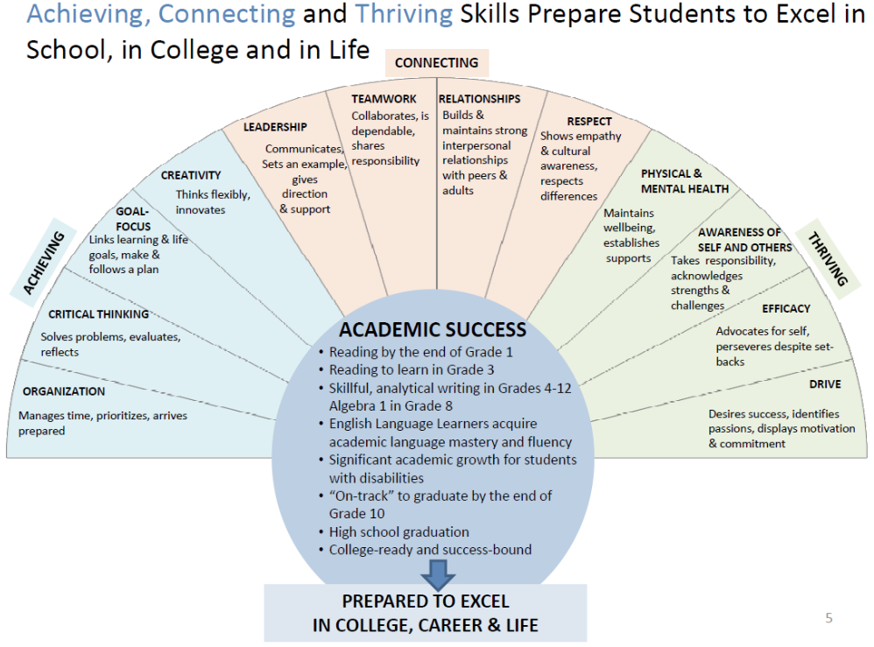

**Program Participation and Opportunities**

|  |  |  |  |  |
| --- | --- | --- | --- | --- |
| **Grade** | **Participation/Stipend** | **Mandatory** | **Opportunities** | **Notes** |
| 7-8 | Classes/Tutoring + Advising  $180/semester | 1 Winter/Spring Break Event | College Tours, Honor Roll Celebrations, Holiday Celebrations, Field Trips | **All students must attend Advising each marking period** |
| 9 | Classes/Tutoring + Advising  $300/semester | 1 College Tour  1 Winter/Spring Break Event  Alumni Panel | Moakley Public Speaking Institute  College Tours, Honor Roll Celebrations, Holiday Celebrations | **All students must attend Advising each marking period** |
| 10 | Classes/Tutoring + Advising  $300/semester | 1 College Tour  1 Community Service  1 Winter/Spring Break Event  Admissions/Alumni Panel | Girls S.E.T. in the City  Whitehead Institute Spring Lecture Series  Moakley Public Speaking Institute (summer)  Sea Science Leadership Program  Camp College overnight (summer) | **All students must attend Advising each marking period** |
| 11 | Fall: Class – Writing Intensive  Spring: SAT/ACT Saturday  Advising  $300/semester | 1 College Tour  1 Community Service  1 Winter/Spring Break Event  1 “Opportunity”  Admissions/Alumni Panel | TRiO Day Overnight  Girls S.E.T. in the City  Whitehead Institute Spring Lecture Series  Moakley Public Speaking Institute (summer)  Sea Science Leadership Program  Dual Enrollment  Summer Internship | **All students must attend Advising each marking period**  **A strong GPA is required for “opportunities” eligibility** |
| 12 | All Year: College Checklist  Fall: SAT/ACT Review  Spring: UMB Course (audit); Dual Enrollment  Summer: MLK Internship | Internship, UCourse, Dual Enrollment  Admissions/Alumni Panel |  | **Completion of College Checklist required for $300 stipend** |
| Alumni | MLK Scholar Internship |  |  | **Must be enrolled in 4-year program** |

**Membership and Continuation in the Program**

Once scholars are accepted in the program, it is their responsibility to take the necessary steps to remain in the program. This includes

* Maintaining a 3.0 GPA in core subjects (ELA/Humanities, Math, Science)
* **Students in mandatory tutoring are required to achieve a GPA increase of .25 each year until 3.0**
* Maintaining a complete and updated portfolio
* Taking the necessary steps for approved program leave
* Meeting attendance requirements (classes, tutoring, advising, and senior checklist) and communicating when this is a problem
* Behaving according to Urban Scholars Student Expectations
* Putting forth 100% effort in all Urban Scholars classes and passing all BPS? classes
* Participating in enrichment programming such as community service, college tours, field trips, honor roll celebrations when eligible, Scholar Council, and more
* Completing necessary requirements to apply to college (College Prep Checklist)

**Between 10th and 11th grade Urban Scholars staff will review portfolios, transcripts, and course evaluations to determine whether each 10th grader will “step up” to 11th grade in the program. At times, the students’ presence will be required.**

**Required Participation by Semester**

**Note: ALL students, even those on leave, participate in Advising and must keep an updated Portfolio.**

Membership in the Urban Scholars Program is ongoing, just like college preparation. All students must participate in at least TWO semesters throughout the year: (1) Fall and Winter, (2) Fall and Summer, (3) Winter and Summer, **or all three!**

**Track A –Classes at UMB**

24 Weeks (2 semesters) - Tuesday and Thursday 3:30-5:30

Expectations

Attendance – In order to gain as much as possible from your classes, you should attend every class.

Advising + Portfolio

Enrichment – participate in at least one event/field trip

**Track B –1-1 and Small-Group Tutoring**

**34 Weeks of 1-1 tutoring – 12 fall; 4 January; 18 spring up to final exams**

**Tutoring Placement:**

**Fall** – upon previous year’s transcript review: any student with

A. 2 core subject* grades of C or below

B. 1 core subject grade of D or below

**Winter** – upon mid-term grade review: any student with

A. 2 core subject grades of C or below

B. 1 core subject grade of D or below

**Election** – should a student, parent, or school personnel request tutoring:

Student will be moved from class to tutoring for the remainder of the semester

* Humanities (ELA, History), Math, Science,

**Track C – Classes at the Institute of Contemporary Art + Tutoring**

25 Hours: ICA scheduled “Pathways” in DJ’ing, Digital Photographing, or Film Making

23 Hours: Tutoring/silent study/Scholar Council at Urban Scholars

**Full Stipend Paid**

**Requirements: 3.25 GPA, good standing in the program, maturity, and strong work ethic**

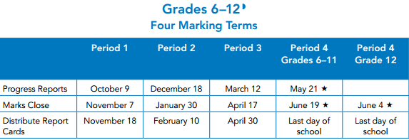

**Weekly Programming**

|  |  |  |  |
| --- | --- | --- | --- |
| **Day** | **Time** | **Activities** | **Location** |
| Monday | **3:00-7:00** | Tutoring | M-2-616, 621 |
| Tuesday | **3:00-7:00** | Tutoring/Classes | M-1-614, 617, 619  M-2-616, 621 |
| Wednesday | **3:00-7:00** | Tutoring | M-2-616, 621 |
| Thursday | **3:00-7:00** | Tutoring/Classes | M-1-614, 617, 619  M-2-616, 621 |
| Friday | **3:00-5:00** | Tutoring by appointment | USP Office |

**Earning a Stipend\***

Stipends are not given, they are earned. This means that there are a number of requirements for earning a stipend:

* Attendance – you are not paid when you are absent
* Effort and Achievement –showing up is the first step; working hard earns you a stipend
* Portfolio – be sure to keep this up-to-date so that all your hard work is documented
* Advising – keep all your appointments; this is where you improve the present and plan for your future.

**In order for scholars to collect their stipends, they must attend the program, keep a complete and up-to-date portfolio and attend the Advising program.**

* For middle school, full attendance earns you $15/week = $180 *each semester*
* For high school, full attendance is $25/week = $300 *each semester*

**\* Please know that we are part of a large, state-funded community that serves 18,000 students, faculty, and staff. We make every effort to ensure scholars are paid in full and on-time – we appreciate your patience if stipends are delayed.**

**Quarterly Advising Program**

Each student is paired with a staff member (Assistant Director, College Counselor, or Program Assistant) and will meet with them at least 3 times throughout the academic year. During these meetings you will

* + Review your portfolio
  + Submit your **report card** – a copy will be made and the original returned to you
  + If the above are complete, **collect your stipend** (unless you are on leave)
  + Discuss academic and social progress towards goals
  + Review and set new goals
  + Discuss opportunities within and outside of Urban Scholars like internships, dual enrollment, UCourses, Community Service, etc.

**Program Leave**

**Definition:** This is a **one-semester** allowance to participate in a school or other organization-sponsored program instead of the Urban Scholars Program.

**Note:** This is granted for ONE SEMESTER ONLY throughout the year. In order for a student to be granted a program leave, he/she **must complete a Program Leave Contract prior to the beginning of the semester (9/23)**. This must be signed by the parent/guardian, student, and organization leader or coach. **This must then be approved by the Assistant Director**. Approval guarantees your continued participation in the program during and after your leave. **If this is not returned, you risk dismissal.**

**Note: All students on approved Program Leave are REQUIRED to participate in Advising while they are on leave.**

**Approved Program Leave Examples**

* + Family, medical, or personal issues as approved by staff
  + After-School sports or clubs meeting regularly in conflict with the USP schedule
  + Documented tutoring at school
  + Art/music/enrichment program or courses at Mass College of Art and Design or other approved organization
  + STEM programs such as MIT’s SEED, Science & Baseball Program, or other approved organization
  + Summer internship
  + Summer program at other approved organization
  + Summer employment coordinated by Private Industry Council (PIC)
  + Extended family travel during the summer (most students still attend our summer program)
  + Other reasons for leave are approved on a case-by-case basis by program staff

**Not Approved Leave Examples**

* + General food service or retail job – i.e. working @ McDonald’s or Target
  + “Not interested this semester”
  + Unspecified or uncommunicated family or personal issue
  + Tentative travel or employment plans

**Portfolio**

Starting this fall, all Urban Scholars will begin a portfolio which will track their participation, progress, and growth throughout their years in the program as they prepare for college. Each scholar will be responsible for keeping their portfolio updated and complete by entering the required documents when necessary.

**Portfolios will be a key component in collecting stipends, reviewing membership in the program, eligibility for field trips, internships, dual enrollment, and more.**

**\* Scholars will bring these portfolios to each of their advising meetings to discuss their work with their advisor and assess their progress.** **Stipends will only be given to students who have complete and up-to-date portfolios.**

**\*\* Students on leave must keep an updated portfolio!**

**What does in the portfolio binder?**

**For All Students**

* + Quarterly report cards and progress reports
  + Reflections on goals, action plans, courses, community service, jobs, field trips, college tours, and more
  + Examples of your best work from school and where you have struggled

**For Students in Class**

* + All the above
  + Example of work from class (essays, pictures of projects, reflections, etc.) and school (papers, tests, etc.)
  + Final evaluation

**For Students in Tutoring**

* + Attendance log
  + Bi-weekly progress reports
  + Copies of graded work
  + School progress reports, report cards
  + Action steps and reflection

**Attendance Policy**

The Urban Scholars Program is not for all students. That’s why you are an Urban Scholar – you are not like all students. You have committed to college graduation and to the hard work and dedication this requires. What is vital for your membership in this program is attendance.

Attendance is one of your primary responsibilities and shows your commitment to the program. Our expectations are that you attend classes, tutoring, advising, and enrichment activities 100% of the time. When you do not show up, the message we get is “Urban Scholars is not a priority.” Many students would like to be Urban Scholars. If you don’t make it a priority, we will give your place to someone for whom USP is a priority with a schedule that allows a commitment to attend.

**We know there may be times when an emergency comes up and you have to miss. It is very important that you communicate with the program when you will be late or absent. A simple phone call or email is ok.**

**TARDY_______________________________________________________________**

1. Call when you expect to be **more than 15 minutes** late.

2. If you are **more than 15 minutes late**, it is counted as an **absence**.

3. If you are late and you

a. call

b. provide documentation

You can still get paid for your attendance.

**ABSENT______________________________________________________________**

1. Call when you expect to be absent.

2. If you are absent and you

a. call before 3:30

b. provide documentation (doctor’s note, teacher’s note and contact info.) when you return

Your absence will be excused. You will not get paid but it will not count against your standing in the program.

3. Please notify Kevin, in advance, that you will be absent..

4. You are not paid for days you are absent whether excused or not.

***\*If you are absent you are required to complete any missed work. Always see your instructor before/after an absence.***

**CONSEQUENCES________________________________________________________**

1. After the 3nd unexcused absence: You will receive a letter requesting a meeting with Kevin or another core staff member to discuss attendance. This letter will also go to your home.

2. Any absence after:

- a meeting with core staff to discuss your continuation in the program and under what conditions.

3. Excessive absences may result in:

* + student being excused from the program
  + students not being eligible for U-Courses, internships, enrichment activities
  + student finishing the semester but not participating in the summer program

**MISS STEPHANIE/MAIN OFFICE #** – (617)-287-5830

**KEVIN** – (617)-287-5827

*LEAVE A DETAILED MESSAGE:

-**FIRST AND LAST NAME**

**-WHY YOU’RE LATE/ABSENT**

**-IF LATE: WHEN YOU’LL ARRIVE**

**Scholar Council**

Do you want more off-campus opportunities and overnight field trips? Different classes? More summer field trips? This is your chance to make that happen!

The Scholar Council is a student-led decision-making organization within Urban Scholars. **Each student is required to sit on the Scholar Council for at least one semester while he/she is in the program.** In general, these meeting take place **twice a month**, last for about an hour, and are organized by a core staff member.

**Sample Scholar Council Activates:**

* Deciding on and fundraising for an single day or overnight field trip
* Holiday Parties (Halloween, Thanksgiving, Winter, Valentine’s Day) – plan and carry out a celebration on campus
* Honor Roll Celebration – research options, design a survey, collect votes, and plan the trip
* Summer Program– working with a budget, plan a fun, exciting event that will connect Urban Scholars with the campus and city community
* Program Policies – We want to hear from you! What do you like about USP? How can we improve?

**Student Celebrations and Honors**

Honoring and awarding student achievement is important. We strive to distinguish students who achieve or exceed their potential in our classes and in school. In addition, we reward hard work, effort, and growth. 3 times each year we take a group of students out to dinner to celebrate their academic achievements. **These events require permission and at least a 3.5 GPA. If space allows, students with a 3.0-3.49 GPA may attend.**

**The dates for this year’s Honor Roll Celebrations are all Wednesdays and on the Academic Calendar.**

**Academic Year Calendar**

|  |  |  |
| --- | --- | --- |
| **Date** | **Event** | **Location** |
| 9/13 – 10am-noon | Fall Orientation 1 | Ryan Lounge |
| 9/16 – 5:30-7:00pm | Fall Orientation 2 | McCormack – 1- 617 |
| Tuesday, 9/23 | **Fall Semester Begins** | McCormack Hall |
| 12/03 | Quarter 1 Honor Roll Celebration |  |
| Thursday 12/11 | **End of Semester - Project Showcase** |  |
| 12/01 – 12/12/2014 | **Advising #1** – bring report card, sign up for winter break programming | USP Office |
| 01/5 – 01/23/2015 | **Mid-Term Exam Tutoring Intensive** |  |
| Tuesday, 01/27 | **Winter Semester Begins** | McCormack Hall |
| 2/26-2/20 | BPS Winter Break – community service, college tours, workshops, and more |  |
| 02/23 - 03/05/2015 | **Advising #2** – bring report card, sign up for spring break programming | USP Office |
| 03/11 | Quarter 2 Honor Roll Celebration |  |
| Thursday, 04/16 | **End of Semester – Project Showcase** |  |
| 4/20-4/24 | BPS Spring Break – community service, college tours, workshops, and more |  |
| 05/04 – 05/15 | **Advising #3** – bring report card, submit completed summer forms | USP Office |
| 05/20 | Quarter 3 Honor Roll Celebration |  |
| 05/04 – 06/12 | **Final Exam Tutoring Intensive** |  |
| 06/22 – 08/07 | Summer Program |  |

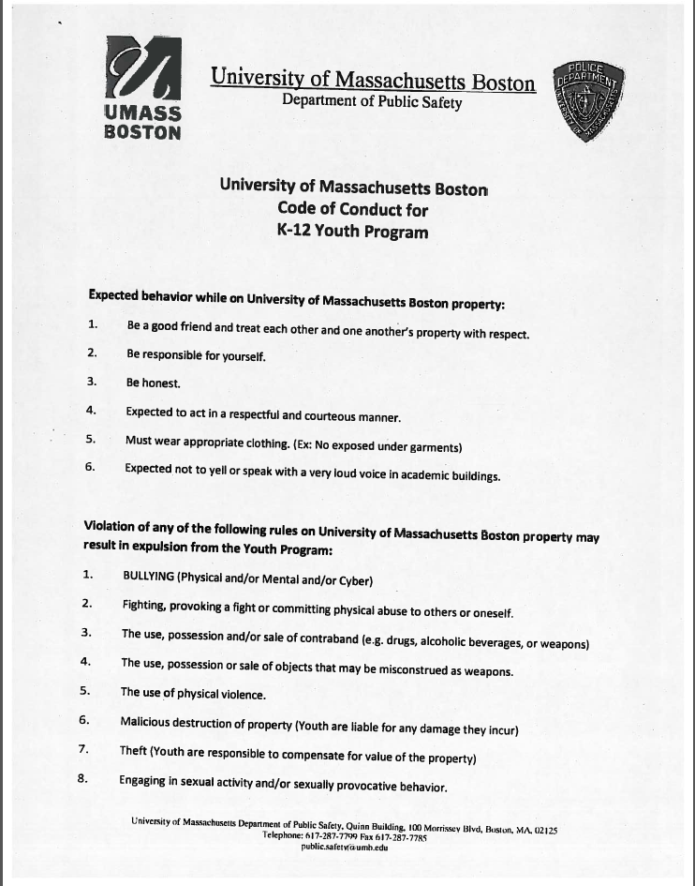

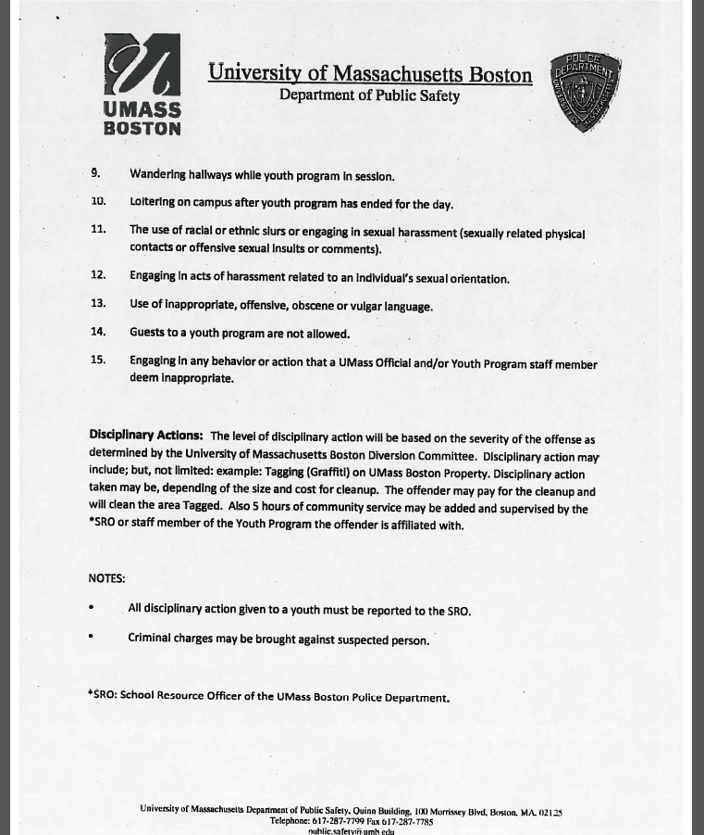

**Statement of Receipt**

By signing below I acknowledge that I have received, read, and understand the information in this handbook and will abide by its policies.

___________________________________________________________________________ ________________________

Urban Scholar Parent or Guardian Date

___________________________________________________________________________ ________________________

Urban Scholar Date

**Fall 2014 Program Leave Contract**

The Urban Scholars Program encourages students to participate in numerous enrichment and extra-curricular activities. We provide many of these including after-school classes, community service opportunities, outdoor recreation, college tours, field trips, and more.

However, students frequently desire to participate in other programs that help prepare them for college.

**IMPORTANT: Students are eligible for a leave from the program ONLY IF they are doing well in school. This means they must have a 3.0 GPA and no grade lower than a “C”. If a student chooses to neglect this rule, they must reapply for admission to the program at a later date.**

In order for students to remain in the Urban Scholars Program AND take a leave to participate in outside programs, **communication is necessary.**

This document does 2 things:

1. Serves as a “**contract of understanding**” between the student, parent, and program.

2. **Guarantees the student may continue participation** in the Urban Scholars Program during and after their leave.

**If you agree to the above, please sign and return to the Urban Scholars office**

**REASON for program leave: ___________________________________________________________________________**

**Length of program leave:**

**_____________________________________________________________________________**

____________________________________________________ __________________

Student Date

____________________________________________________ __________________

Parent/Guardian Date

____________________________________________________ __________________

School/Program Official Date

**Attendance Warning Letter**

Date

Dear ______,

It has come to our attention that you have been absent from your Urban Scholars class a total of **3** times since the beginning of the semester (dates absent). Our program has a strict attendance policy which requires you to be present for classes in order to help you prepare for success in college.

Our attendance policy allows for 3 unexcused absences. We accept excuses when they are documented and you communicate with our core staff.

Due to the number of absences, you are being given an **Attendance Warning.**

**Next steps:**

1. Immediately schedule a meeting with Kevin Dean at the USP office to discuss your absences.

2. Attend all required classes for the rest of the semester.

3. Put forth effort in your class and earn a passing grade.

**Consequences:**

If you **do not schedule a meeting within one week** of receiving this, you will be excused from the Urban Scholars Program. You can apply again later.

If you decide you want to continue and **have another unexcused absence** you will be immediately excused.

If you have any questions or concerns, do not hesitate to call me at (617)-287-5827 or email at kevin.dean@umb.edu.

Sincerely,

Kevin Dean

Assistant Director

**Letter of Dismissal**

Date

Dear Parent/Guardian of ________________________,

Due to your daughter’s prolonged absence (dates) and lack of communication (details), she has been dismissed from the Urban Scholars Program at UMass Boston as of today (date). Should she wish to rejoin she must reapply for admission.

Please contact Kevin Dean, Assistant Director at [kevin.dean@umb.edu](mailto:kevin.dean@umb.edu) or (617)-287-5827 with any questions or concerns.

Sincerely,

Kevin Dean

Assistant Director