**Urban Scholars Program**

**Instructor Handbook**

**Summer 2014**

UMBformalblue

**Table of Contents**

**Mission and Core Staff_______________________________________________________________________________________________________3**

**Responsibilities and Expectations_________________________________________________________________________________________4**

**Youth Development at Urban Scholars___________________________________________________________________________________5**

**Curriculum and Instruction at USP________________________________________________________________________________________6**

**Project-Based Learning at USP_____________________________________________________________________________________________7**

**Week 1_________________________________________________________________________________________________________________________8**

**USP Student Expectations___________________________________________________________________________________________________9**

**Operations___________________________________________________________________________________________________________________10**

**Safety and Emergency______________________________________________________________________________________________________11**

**Mandated Reporting _______________________________________________________________________________________________________12**

**Classroom Management___________________________________________________________________________________________________13**

**Policies and Procedures: Student Behavior________________________________________________________________________14-15**

**Teaching Assistants____________________________________________________________________________________________________16-17**

**Week 7________________________________________________________________________________________________________________________17**

**Appendix**

* + Sample Syllabus Topics (19)
  + Lesson Plan Template (20)
  + Mid-Summer Progress Report (21)
  + Final Evaluation (22)
  + Course Evaluation (23-24)
  + Summer Calendar (25-26)
  + Classroom Management Plan Template (27-29)
  + Course Description and Common Core/MA Framework Course Alignment (30-31)
  + Universal Design for Learning Guidelines (32)
  + Scholars Dollars (33)
  + Course Master Schedule (34-36)
  + Human Resources Information (37)
  + UMB Campus Map (38)

**Program Mission and Vision**

* We are a year-round *college preparation program* for academically talented and focused low-income/first-generation BPS students in grades 7-12 who desire a college education.
* We work with specific “partner schools” to recruit students.
* We seek to cultivate life-long learners who lead healthy and productive lives impacting the local and global community in positive ways.
* We prepare students for college by
  + Ensuring their academic records are strong
  + Ensuring they have college-ready skills
  + Ensuring they are developing into thoughtful, well-rounded, success-oriented individuals

**Core Staff**

|  |  |  |
| --- | --- | --- |
| David Lemmel, Director | 401-215-4717 | david.lemmel@umb.edu |
| Kevin Dean, Asst. Director | 301-533-6629 | kevin.dean@umb.edu |
| Suamy Ventura, Program Assistant | 617-318-8505 | suamy.ventura@umb.edu |
| Stephanie Hicks-Williams, Office Manager | 857-492-6341 | stephanie.williams@umb.edu |
| Akunna Rosser, College Counselor/Recruiter | 617-838-5257 | akunna.rosser@umb.edu |

**Lead Teacher:** Chris Kelly will serve as the Lead Teacher this summer. He has been associated with USP for over 10 years and is an excellent, experienced public school teacher. Along with serving in this role, Chris will be teaching 2 sections of our “Boston Strong” course. When not teaching, Chris will be in classrooms observing and supporting instruction, supporting our teaching assistants, meeting 1-1 with instructors, and documenting teaching and learning at USP. Please use him as a resource to ensure your course is progressing well!

**Responsibilities and Expectations – USP Instructors**

**Pre-Summer**

* + Submit a scope and sequence of a project-based course
  + Meet with Assistant Director to discuss course
  + Complete employee paperwork including a CORI
  + Submit materials order
  + Attend instructor orientation
  + Submit course syllabus (see Appendix) and pre-test before the first day of class

**Throughout the summer:**

**Professionalism:**

* + Arrive on-time to teach courses.
  + Call the office and your TA when you expect to be late or absent.
  + Refrain from releasing students early or leaving them unsupervised at any time; maintain a safe and productive learning environment at all times.
  + Take accurate attendance for each class.
  + Attend weekly instructor meetings (Wed. 12:45pm).
  + Treat all USP and UMB staff and students with respect.
  + Practice cultural awareness and sensitivity.
  + Refrain from interacting with students via social media or private e-mail.
  + Maintain student assessment records aligned to program goals.
  + Directly supervise and support the Teaching Assistant.
  + Monitor student behavior and safety, communicating issues with core staff.
  + Attend the USCARS Summer Celebration event.

**To Complete:**

* + Submit 2 lesson plans each week for the upcoming week (due by Friday) (see Appendix for template).
  + Hold 1-1 meetings with students during week 3.
  + Complete Mid-Summer Progress Report (see Appendix).
  + Submit course description/alignment document by week 4 (see Appendix).
  + Coordinate projects to be ready to present during the Project Showcase.
  + Submit nominations for student awards.

**Post-Summer**

* Complete final evaluations on time (8/22) (see Appendix)

**If you are absent, please provide a lesson plan for those classes. This should be submitted as early as possible so teaching assistants can best impact student learning. Reminder: instructors are *not* compensated for days absent.**

**Youth Development at Urban Scholars**

**USP provides a wide variety of experiences and opportunities designed to help our students excel in school, college, and life. The summer program is a key component in each scholars’ development and is designed to challenge students, cultivate and uncover talents, and strengthen our community in a supportive and engaging environment. We have adopted the “Achieving-Connecting-Thriving” (ACT) framework to center our work and bring cohesion to our philosophy.**

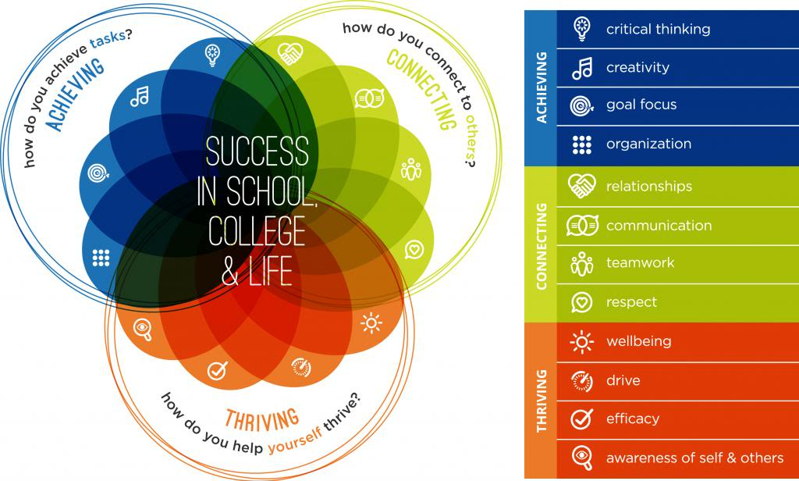

**Curriculum and Instruction at Urban Scholars**

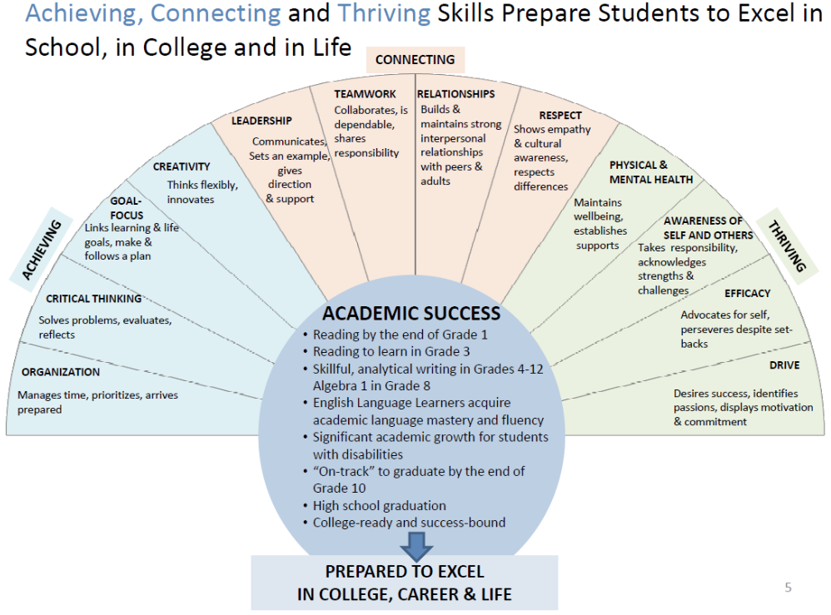

Please use the information above to embed these skills in your course through curriculum, routines, feedback, assessment, learning activities, and classroom management. It is important to “mine” your course for areas where you can provide depth of learning by focusing on 3-5 areas. When focusing on these skills, be explicit and teach students the skills they are learning and how to improve upon the chosen area.

These areas correspond to our mid-summer progress report generally and our final evaluation specifically.

**Project-Based Learning**

USP Academics has always been rooted in projects. However, we are strengthening our approach to Project-Based Learning (PBL) and are viewing our academics through this lens. The fundamentals of PBL rest in planning units and full courses that

* + Align to quality **learning standards** (Common Core Standards/MA Frameworks) and **21st Century Skills**
  + Are **planned backwards** to ensure learning time is maximized
  + Are **student-centered and inquiry-driven**
  + Are **inclusive** where student roles/responsibilities are clear and varied
  + Support all students and are **differentiated**
  + **Clarify and focus on relevant**, **specific learning outcomes**
  + Do not rely on traditional teacher-centered approaches but more on a **“teacher-as-coach” model**

The planning approach is below, with “manage the process” being the final step and where the bulk the day-to-day classroom activity lies. Obviously, **planning** is the key component here.

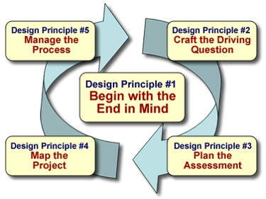

**Week 1 at Urban Scholars**

Week 1 is a busy time at Urban Scholars. You should complete the following:

* + A course syllabus to discuss with students
  + A pre-test to administer during this week
  + 2 lesson plans submitted prior to this week

|  |  |  |  |  |
| --- | --- | --- | --- | --- |
| **Monday** | **Tuesday** | **Wednesday** | **Thursday** | **Friday** |
| 1st Day of USP Summer  No Classes  Team Building + BBQ  Instructors Welcome | 1st Day of Classes  Syllabus Review; Pre-Test administered; Ice-breakers and class culture work | Regular Class Day | Regular Class Day  Instructor Meeting @ 12:45pm – Urban Scholars Office | No Class – Independence Day |

**Urban Scholars Student Expectations**

As a UMB youth program, the Urban Scholars Program abides by the university’s code of conduct for K-12 programs. In addition, as a learning community, we commit to living up to high expectations so as to support one another’s growth and ensure safety, engagement, and enjoyment.

* **High Expectations = the BEST versions of ourselves**
* **Core Expectations:**
  + **Respect**
  + **Community**
  + **Engagement**
  + **Persistence**
  + **Achieving – Thriving - Connecting**

**An Urban Scholar is…**

* **Always on-time, ready to learn**
* **Engaged and participates**
* **Respectful; helpful; concerned for others and their well-being**
* **Positive, optimistic, and a team-player**
* **A hard worker and consistent, clear communicator**
* **Focused on success and driven to achieve**
* **Someone who asks questions, seeks and provides assistance**
* **Seeks out opportunities, takes on challenges, and holds a growth mindset**

**Operations**

**Classroom Assignments (all Wheatley Hall- 1st Floor)**

**\*No materials may be left in classrooms after 12:45.**

**Wireless Connection**

**USER ID: urbanscholars**

**PASSWORD: Boston33**

**AV Box Code: 039**

**Material Orders** – please be mindful of cost – order at least 2 weeks in advance

Please use the following format

**Item Name Cost # needed Web link (Office Max or Amazon) Total Cost**

**Pay Schedule – Bi-Weekly**

HR issues/questions – please contact HR Dept. personnel (see Appendix).

Accessing pay stubs online – HR Direct (see Appendix).

**Class Binders**

**Attendance - please complete - T = Tardy (include min.), A = Absent, P = Present**

**\*Stipends depend on accurate reporting!**

Copies, class handouts

Instructor Handbook

Pick up/return from shelves next to Stephanie’s desk or keep in class materials bin.

**Supply closet** – paper, pens/pencils, **laptops (must be signed out**), **hard drives (must be signed out)**

Combination – **20-30-24**

Laptops and Hard Drives – instructors are charged for any losses/damages when in their care

**Copy Machine – 15921**

**USP Gmail Address:** [**urbanscholarsumb@gmail.com**](mailto:urbanscholarsumb@gmail.com) **pass: Usp_2*13**

**Safety and Emergency**

Safety is paramount to our work during the summer and is a top priority. As members of an open campus and large university community of all ages, it is important that we do our best to make students feel welcome and to ensure they are safe and protected. Be concerned for student safety at all times in the classroom and in common areas. This includes:

* + Ensuring students are moving to class and not loitering in unsupervised areas
  + Classroom hazards are reported to USP staff immediately
  + Students are engaging with program staff and peers, avoiding engaging with other adults on campus
  + Students and staff are respectful of one another and university facilities at all times.

**To Note:**

**1. UMB has a Health Services office and clinic on-campus for all student health needs. Our students have full access to this care.**

**2. ALL interns are trained in CPR/First-Aid. They are aware of the proper notification procedures in case of an emergency.**

However, use your best judgment when evaluating an emergent situation:

* + Should you see blood, an unconscious child, head trauma or other severe injury, call 9-1-1 and notify the UPS office/staff member ASAP.
  + Should a child be unwell in your classroom (stomach ache, fever, soreness) and express this to you, **send this student, with your intern, to University Health Services (UHS)**. The intern will notify the USP office then. Interns may not leave the child alone either on their way to UHS or at UHS.
  + If you sense a child is uncomfortable or unwell and has yet to say anything, pull the child aside and determine if they require assistance. If appropriate, send them to UHS with the intern as above.
  + ***Never send students to the office if they are unwell – we cannot administer health services there***.

We appreciate your assistance in helping our scholars enjoy a safe and productive summer!

**Mandated Reporting**

<http://middlesexcac.org/51A-reporter-training/>

**What is a Mandated Reporter?**

Mandated Reporters are persons who, as a result of their profession, are more likely to be aware of abuse or neglect of persons under their supervision. Mandated Reporters are required by law to report cases of suspected abuse.

**What is Reportable?**

The standard for reporting suspected abuse and neglect is "reasonable cause to believe" which means that mandated reporters need only a " **mere suspicion**" that abuse or neglect was committed against a minor. **If abuse or neglect is suspected, contact Assistant Director, Kevin Dean at the next available moment. If he is absent, contact Director, David Lemmel or College Counselor, Akunna Rosser**. It is better to err on the side of action.

When reporting, please communicate in person, if possible. If not, please call.

**Protection for Mandated Reporters who Report Abuse**

Mandated Reporters are immune from civil or criminal liability as a result of filing a report of abuse committed against a minor. Non-mandated reporters are also protected providing the report was made in good faith. If a Mandated Reporter is retaliated against by their employer for filing an alleged report of abuse, or by participating in the DCF investigation, DCF will conduct an investigation into the retaliation.

**Consequences for Not Reporting Crime, Abuse and Neglect Committed Against Minors**

In Massachusetts, Mandated Reporters can be fined up to $1,000 for failure to report incidences of suspected abuse and neglect of children, elders, and individuals with disabilities.

The failure to report crimes and incidences of suspected abuse and neglect committed against persons can result in severe consequences for the alleged victim, other potential victims, and the Mandated Reporter. Victims of abuse and neglect are at increased risk of further abuse, if it goes unreported. The frequency and severity of abuse and neglect are likely to increase over time if no intervention is made. A failure to intervene by not reporting will likely result in other individuals being abused and neglected.

**In short, Urban Scholars assumes liability for all reports submitted to our core staff and will process all reports accordingly. However, should you suspect abuse or neglect and not communicate with core staff, you are liable for penalties under law.**

**Classroom Management**

Establishing and maintaining a safe, productive classroom is essential in creating a positive educational experience for our scholars. **To this end, a few policies and practices are meant to be consistent and uniformly applied by all teachers. They are:**

* + No cell phones are allowed visible in class – Instructors may take cell phones and return at the end of the class.
  + Students should not use the restroom during the first 5 or last 5 minutes of class.
    - Encourage the students to use the restroom between classes.
    - Students should use the bathroom one-at-a-time.
  + Students should arrive to class on-time.
    - To strengthen accountability, incorporate this into a class participation grade, for example.

In general, you should hold high expectations for student participation, behavior, and work ethic. However, be sure your expectations are clear and your feedback reinforces the behavior you expect.

**Other management techniques we strongly encourage are**

* + Positive reinforcement and encouragement
  + Peer accountability
  + Plan for class transitions
  + Structure each class with a “Do Now” to focus students immediately
  + Establish clear roles and expectations for collaborative work – reinforce them
  + Use the TA to manage persistent issues – take the student for a walk or to the office if severe
  + Friendly, amicable, and positive approaches – we are not here to intimidate, embarrass or otherwise make students feel uncomfortable; how fun but be productive and hold high standards
  + Plan for addressing high-achieving and developing behavior (see Classroom Management Template in the Appendix).

Being consistent, clear, and always fair will ensure you are building positive class culture and focusing students on learning and personal growth.

**Scholar Dollars**

Scholar Dollars are meant to reinforce high expectations in and out of the classroom. They can only be issued by instructors (not TA’s) and should only be used when students exceed expectations, show significant growth, display leadership in the classroom or otherwise set an excellent example. Excellent classwork, while earning the scholar high marks, should not be rewarded with a Scholar Dollar.

Each Scholar Dollar equals one team point. **Please write your name and the scholars’ name on the ticket. Students should turn these in to Suamy or Kevin for a conversation and credit.**

**Like most incentives/rewards, when used sparingly yet consistently, and coupled with a clear explanation, they can be an effective classroom tool.**

**Procedures and Consequences for Behavioral Issues**

To ensure a productive and consistent approach to discipline, these procedures are intended to inform both staff and scholars of the discipline process and consequences for unacceptable behavior. These steps are not meant to punish scholars but to ensure that, if behavior becomes an issue affecting the learning of others, there is a set of procedures in place to facilitate improvement. We approach discipline from a “teachable moment” standpoint and hold scholars to high expectations yet understand they are developing and make mistakes. Of course, we would like to use these means as rarely as possible and trust that teachers will handle minor classroom disruptions as they arise. **Please communicate these procedures to scholars on the first day of class.**

**Note: Major Disruptions/Severe Behavior**

**In the case a scholar is acting wholly inappropriate towards staff or classmates, s/he should be immediately removed from class and sent with the intern to the main office (once the scholar is received, the intern may return). Behavior warranting this may include**

* + - **Bullying/Harassment – physical, sexual, verbal (offensive language, racial slurs), intimidation**
    - **Vandalism of UMB property**
    - **Repeated, excessive tardiness**
    - **General disrespect**
    - **Possession of drugs or alcohol**

1. Disruption

-If a scholar’s behavior is significantly affecting the teacher’s ability to conduct a productive lesson in a safe classroom environment, the teacher may ask the scholar to leave the classroom for a period of time. Behavior warranting this may include creating significant, distracting, and persistent noise, coming frequently unprepared, distracting others, or refusing to comply with a reasonable request.

-Have the classroom assistant escort the scholar out of the instructional setting for a brief period of time to “cool off.” **Follow-up with core staff the same day.**

1. Continued Disruption (same class)

-If the scholar is readmitted and the behavior continues, the teacher may send the scholar to the main office **with the classroom assistant** who will report to Kevin what happened.

-The core staff will take appropriate measures thereafter. Core staff will communicate actions taken with the instructor.

*The teacher is encouraged to dialogue with the scholar before the next class regarding the event to ensure the scholar knows what exactly the problem was and there is an opportunity to improve.

1. Continued Disruption (over multiple classes)

-Should a scholar be sent out of class twice, he/she will conference with the teacher and a member of the core staff regarding their continuation in the course.

-He/she will also be excluded from enrichment activities for a determined amount of time.

-If deemed necessary by core staff, a parent or guardian will be contacted.

-The scholar will develop an action plan to alter his/her behavior and sign this with the instructor and a member of the core staff.

**-If the behavior continues, core staff will determine the future of the scholar’s participation in the program.**

**Teacher and Teaching Assistant: Roles, Ideas, Opportunities**

**Overview**

Classroom assistants at Urban Scholars are excellent resources. They can be essentials tools for preparing the learning environment, conducting academic conversations, differentiating instruction, assessing progress, and facilitating small-group instruction. What is essential is that you are intentional about the TA’s role, communicating what behaviors you expect, and providing feedback/guidance. As you begin the summer, consider using some of the following ways to maximize student learning in the classroom setting. These are only a few options and a combination of approaches is advised.

Overall, we expect our intern’s role in the classroom to include:

* + - Preparing the learning environment (i.e. gather materials before class, return them at the end, grab a resource during class if needed)
    - Being fully and actively engaged in the lesson, whatever their role on a particular day is, and be communicative with you – assuming the position of learner and leader of learners
    - Being consistent with classroom/teacher and program-wide policies/expectations
    - Modeling high expectations, enthusiasm for learning, and challenging students to excel
    - Communicating student issues with core staff
    - Ensuring hallways are safe, quiet, and orderly
    - Ensuring scholars are moving to class on time

***Whole Group Instruction***

**Both Teach**

Depending on the activity, some situations benefit from both teachers taking an active role in instruction. Academic discussions, for example, can benefit from the enrichment provided by the perspectives of both teachers and may ensure everyone participates.

**TA as Supporting Differentiation**

For example, the assistant can write notes on the board while the teacher presents the lesson. Or, the assistant can circulate the class checking for accurate note-taking, answering questions, and supporting English Language Learners. As long as the TA’s role has been clearly communicated and developed, this can be very effective.

**TA as Observer**

This may be very useful in the first week of class. As the teacher and scholars move through the lesson, the assistant can gather specific information about particular scholars’ strengths, weaknesses, and areas in need of immediate or long-term improvement. This data can inform lesson planning and differentiated instruction approaches. Of course, a passive observer serves little purpose.

**TA as Drifter**

This is an extension of the idea above where the assistant takes a more active role in correcting assignments, answering questions, monitoring behavior, checking homework, working with small groups, etc.

**TA as Shadow**

The teacher’s lead instruction is rephrased or re-explained by the TA. This may be especially useful with scholars whose native language is not English and when providing complex, multiple-step instructions. Checking for understanding this way can be very effective.

***Small Group Instruction***

**Station Teaching**

Teachers divide the physical classroom space into two or more parts (e.g., reading comprehension and writing). Students move from station to station with the same instructor or the instructors remain at the stations while the students move. This is a great way to create an active classroom, differentiate instruction, and introduce hands-on activities.

**Extension Instruction**

This provides yet another way to differentiate instruction. As you become more familiar with your scholars, you may introduce activities that allow one instructor to support those struggling with a particular concept while the other introduces something new to the students who are ready to move forward. Focus on the comprehension of individual concepts and the building of particular skills, instead of repeatedly separating the “smart” ones from the “struggling” ones.

**Week 7 at Urban Scholars**

Our final week is a busy one with many moving pieces. Be sure to be preparing projects, post-tests, award nominations, and time for course evaluations plenty ahead of time!

|  |  |  |  |  |
| --- | --- | --- | --- | --- |
| **Monday** | **Tuesday** | **Wednesday** | **Thursday** | **Friday** |
| Regular Class Day  Final Prep for Project Showcase  Course evaluations completed  Post-Test completed | 9:00-10:00 – Moving and setting up projects in the Ryan Lounge  10:00-12:00 – Showcase in the Ryan Lounge  Final Award Nominations Submitted | No Classes – Field Day  Volunteers welcome | 10:00-12:00 – Ryan Lounge  USCARS Graduation  And  Celebration  All staff attend | Canobie Lake Amusement Park |

**APPENDIX**

**Suggested Syllabus**

Title, intro, class and student expectations, materials

* Purpose – Why learn how to ________?
* Relevance – Why should *I (the student)* learn about/how to _________? What does this have to do w/college prep and success?
* Essential questions this experience will help me answer about myself/the world/society/the arts… What’s the big idea(s)?
* Assessment – how will *I* know if I succeeded? What steps along the way will inform me and my instructor of my progress?
* Final Project description and **Rubric**
* Grading/assessment - % breakdown of how the grade will be determined – i.e. 20% class participation; 20% written work; etc.

Feel free to add/adjust as needed.

**Lesson Planning**

|  |
| --- |
| Lesson Objective (content): |
| Lesson Objective (language): |
| Essential Question(s):  Essential Skill(s) (A-C-T):  Warm-up/Hook/Do Now:  Learning Activities:  Evidence of Learning: |
| Connection to Final Project: |
| Independent Practice: |
| Teaching All Students: |

**Urban Scholars Mid-Summer Progress Report**

|  |  |
| --- | --- |
| Student: | Instructor: |
| Subject: | Course Grade: |

|  |  |  |  |  |  |  |
| --- | --- | --- | --- | --- | --- | --- |
|  | |  |  |  |  | **Comments** |
| **Academic Performance** | | **Always** | **Often** | **Sometimes** | **Rarely** |  |
| 1. Demonstrates understanding of the concepts | |  |  |  |  |
| 2. Focuses on class work at all times | |  |  |  |  |
| 3. Performs well on written work | |  |  |  |  |
| 4. Asks questions when unsure | |  |  |  |  |
|  | |  |  |  |  |
| **Social Performance** | | **Always** | **Often** | **Sometimes** | **Rarely** |
| 5. Is present, on time, and prepared to learn | |  |  |  |  |
| 6. Participates appropriately in class activities | |  |  |  |  |
| 7. Exhibits positive attitude & behavior toward teachers, peers, and learning | |  |  |  |  |
| 8. Shows cooperation when working with peers | |  |  |  |  |
| 9. Shows best effort and persistence on difficult tasks | |  |  |  |  |
|  | Comments (achievements, progress, strengths/areas to improve): | | | | | | |

**Final Evaluation – Summer Institute**

**Instructors:** These are vital in framing student success and continuing student growth. Please take the time necessary to provide **thoughtful, evidence-based feedback** for scholars – this is your final teaching opportunity! For #1 and #2, please address each category (A-C-T) through one particular skill per category (i.e. Creativity for Achieving; Teamwork for Connecting; Efficacy for Thriving), choosing a different set of skills for #1 and #2.

|  |  |
| --- | --- |
| Student: | Instructor: |
| Course: | Date: |

*Each category below represents a vital skill area that will help each Urban Scholar prepare to excel in school, in college, and in life. After reading your instructor’s feedback, write* ***3 Action Steps*** *that will help you continue to build upon your strengths and areas where you should improve.* ***These will form your year-long Academic Advising Action Steps.***

1. The scholar has displayed the following **strengths** throughout the course:
   1. Achieving (Organization; Critical Thinking; Goal-Focus; Creativity)
   2. Connecting (Leadership; Teamwork; Relationships; Respect)
   3. Thriving (Physical/Mental Health; Awareness of Self/Others; Efficacy; Drive)
2. The scholar should **work hard to improve** in the following areas:
   1. Achieving (Organization; Critical Thinking; Goal-Focus; Creativity)
   2. Connecting (Leadership; Teamwork; Relationships; Respect)
   3. Thriving (Physical/Mental Health; Awareness of Self/Others; Efficacy; Drive)
3. To what extent did the scholar demonstrate competency in the following academic skill areas in the course: *following directions, asking questions, using resource or reference materials, public speaking, problem-solving, preparing visual aids, reading, writing, speaking, and listening.*

|  |  |
| --- | --- |
| Final Grade: | Note: work NOT completed (homework, class work, quizzes, etc.) |

_________________________________ ______________________________

Instructor’s signature

**For the scholar to complete and bring to Advising #1: What action steps can I take to improve?**

1. ______________________________________________________________________________________________________________________

2. ______________________________________________________________________________________________________________________

3. ______________________________________________________________________________________________________________________

**Course Evaluation Survey**

Course Title: _____________________________________________________________________________

Grade Next Year: ________________ Instructor’s Name: _____________________________________

Directions: **5 = “Totally Agree” or “Always”** **1 = “No” or “Never”**

*1

Were you satisfied with the course content?

|  |  |  |  |  |  |
| --- | --- | --- | --- | --- | --- |
|  | 1 | 2 | 3 | 4 | 5 |
|  | | | | | |
|  |  |  |  |  |  |

*2

Did the instructor clearly present information and the goals of each lesson?

|  |  |  |  |  |  |
| --- | --- | --- | --- | --- | --- |
|  | 1 | 2 | 3 | 4 | 5 |
|  | | | | | |
|  |  |  |  |  |  |

*3

Was the instructor well organized and prepared for classes?

|  |  |  |  |  |  |
| --- | --- | --- | --- | --- | --- |
|  | 1 | 2 | 3 | 4 | 5 |
|  | | | | | |
|  |  |  |  |  |  |

*4

Did instructor show enthusiasm toward the subject matter?

|  |  |  |  |  |  |
| --- | --- | --- | --- | --- | --- |
|  | 1 | 2 | 3 | 4 | 5 |
|  | | | | | |
|  |  |  |  |  |  |

*5

Were you satisfied with the instructor's teaching?

|  |  |  |  |  |  |
| --- | --- | --- | --- | --- | --- |
|  | 1 | 2 | 3 | 4 | 5 |
|  | | | | | |
|  |  |  |  |  |  |

*6

Did the instructor's classroom lectures and activities help you in learning the material?

|  |  |  |  |  |  |
| --- | --- | --- | --- | --- | --- |
|  | 1 | 2 | 3 | 4 | 5 |
|  | | | | | |
|  |  |  |  |  |  |

*7

How clearly did your instructor explain difficult material?

|  |  |  |  |  |  |
| --- | --- | --- | --- | --- | --- |
|  | 1 | 2 | 3 | 4 | 5 |
|  | | | | | |
|  |  |  |  |  |  |

*8

Did the instructor have a positive attitude? Was he/she encouraging and respectful of students?

|  |  |  |  |  |  |
| --- | --- | --- | --- | --- | --- |
|  | 1 | 2 | 3 | 4 | 5 |
|  | | | | | |
|  |  |  |  |  |  |

*9

How beneficial were the materials and activities used by the instructor and you?

|  |  |  |  |  |  |
| --- | --- | --- | --- | --- | --- |
|  | 1 | 2 | 3 | 4 | 5 |
|  | | | | | |
|  |  |  |  |  |  |

*10

How would you rate the instructor's overall performance in this course? **5** is *Superior*. **1** is *Poor*.

|  |  |  |  |  |  |
| --- | --- | --- | --- | --- | --- |
|  | 1 | 2 | 3 | 4 | 5 |
|  | | | | | |
|  |  |  |  |  |  |

*11

Rate the difficulty of this Urban Scholars course compared to other Urban Scholars courses. **5** is *VERY DIFFICULT*. **1** is *VERY EASY.*

|  |  |  |  |  |  |
| --- | --- | --- | --- | --- | --- |
|  | 1 | 2 | 3 | 4 | 5 |
|  | | | | | |
|  |  |  |  |  |  |

*12

Rate the difficulty of this Urban Scholars course compared to Boston Public courses. **5** = *Very Difficult*. **1** = *Easy*.

|  |  |  |  |  |  |
| --- | --- | --- | --- | --- | --- |
|  | 1 | 2 | 3 | 4 | 5 |
|  | | | | | |
|  |  |  |  |  |  |

*13

Did the content/subject and activities connect to your life in any way?

|  |  |  |  |  |  |
| --- | --- | --- | --- | --- | --- |
|  | 1 | 2 | 3 | 4 | 5 |
|  | | | | | |
|  |  |  |  |  |  |

14. What aspects of the course would you change? What did you find least helpful?

____________________________________________________________________________________________________________________________________

____________________________________________________________________________________________________________________________________

____________________________________________________________________________________________________________________________________

15. Describe one assignment, activity, or exercise that was especially meaningful or helpful. What was so good about it?

|  |  |  |  |  |  |  |
| --- | --- | --- | --- | --- | --- | --- |
|  | | Monday | Tuesday | Wednesday | Thursday | Friday |
| **Week 1**  **Give Pre-Test before Friday** | | June 30  First Day for Students | July 1  First Day of Classes | July 2 | July 3  Instructor Meetings (choose 1)  11:30 @ USP Office  12:45 @ USP Office | July 4  CLOSED |
| **Week 2** | | July 7 | July 8 | July 9  Instructor Mtg 12:45 | July 10 | July 11 |
| **Week 3**  **One-on-One mtgs** | | July 14 | July 15 | July 16  Instructor Mtg 12:45 | July 17 | July 18  **Progress Report #1 Due** |
| **Week 4** | | July 21 | July 22 | July 23  Instructor Mtg 12:45 | July 24 | July 25 |
| **Week 5** | July 28 | | July 29 | July 30  Instructor Mtg 12:45 | July 31 | August 1  **USP Cultural Day** |
| **Week 6** | August 4 | | August 5 | August 6  Instructor Mtg 12:45 | August 7 | August 8  **USP Talent Show** |
| **Week 7**  **Post-Test**  **Course Evaluation**  ----------------------- | August11 | | August 12  **Project Presentations**  **10:00-12:30** | August 13  NO CLASSES  FIELD DAY | August 14  NO CLASSES  USCARS Celebration  **@ 11:00AM**  **Location TBD** | August 15  NO CLASSES  Canobie Lake Field Trip |

**Summer Calendar - Instructors**

**Important Dates**

* Tuesday, 7/1 – Classes Begin
* Friday, 7/4: USP Closed
* Week 3: One-on-One Meetings w/students
* **Friday, 7/18: Progress Reports Due**
* **Tuesday 8/12: Project Presentations**
* **Wednesday, 8/13: NO CLASSES – Field Day**
* **Thursday, 8/14: USCARS Celebration @ 11am**
* Week 7: Post-test; course evaluations
* **Friday, August 22: FINAL EVALUATIONS DUE**

**Classroom Management Plan Template**

|  |  |  |  |  |  |  |  |  |  |  |
| --- | --- | --- | --- | --- | --- | --- | --- | --- | --- | --- |
| **Teacher:** |  |  | |  | | | **Grade Level:** | | |  |
| **Level of Structure:** | |  | **Low** | |  | **Medium** | |  | **High** | |
|  | | | |  | | | | | | |
| **Guidelines for Success:** | | | | **Posted Rules:** | | | | | | |
| **Attention Signal:** | | | | | | | | | | |
| **Expectations for Classroom Activities and Transitions:** | | | | | | | | | | |
| **Encouragement Procedures (Motivation):** | | | | | | | | | | |
| **Correction Procedures for Misbehavior (both early-stage corrections and rule violation consequences):** | | | | | | | | | | |
| **Beginning and Ending Routines:**   1. Routine for how students will enter the room: 2. Routine for how students will be instructionally engaged while attendance is taken and for how opening business is conducted: 3. Routine for dealing with tardy students: 4. Routine for dealing with students who come to class without necessary materials: 5. Routine for dealing with students returning after an absence: 6. Routine for wrapping up at end of day/class: 7. Routine for dismissal: | | | | | | | | | | |
| **Procedures for Managing Student Work:**   1. Procedures for assigning classwork and homework: 2. Procedures for collecting completed work: 3. Procedures for keeping records and providing feedback to students: 4. Procedures and policies for dealing with late and missing assignments: | | | | | | | | | | |
| **Procedures for Managing Independent Work Periods** | | | | | | | | | | |

**Common Core Standards/MA Frameworks Course Alignment Samples**

**Course Title: Physics, Calculus…Rollercoasters!**

This class will be an introduction to many important scientific (mostly Physics) and mathematical (mostly Calculus) concepts involved with riding and designing roller coasters, as well as other amusement park rides. Roller Coasters are fast, breathtaking and use a surprising amount of physics to make them as safe and enjoyable as possible. We will explore many of these topics, doing lots of fun demonstrations, experiments and problem-solving along the way, leading up to the design of your very own rollercoasters, using many of the key ideas and work from the semester.

* **CCSS.Math.Content.HSA-CED.A.2:** Create equations in two or more variables to represent relationships between quantities; graph equations on coordinate axes with labels and scales. **Often this term we will create equations that represent relationships between many physical quantities such as time and acceleration for objects in motion.**
* [**CCSS.Math.Content.HSA-CED.A.4**](http://www.corestandards.org/Math/Content/HSA/CED/A/4) :Re-arrange formulas to highlight a quantity of interest, using the same reasoning as in solving equations. **Students will often need to rearrange a known formula such as F=MA, to solve for the missing variable**.
* [**CCSS.Math.Content.HSF-LE.A.1b**](http://www.corestandards.org/Math/Content/HSF/LE/A/1/b) : Recognize situations in which one quantity changes at a constant rate per unit interval relative to another. **Students will need to analyze the rate of change of various data sets to understand how one variable changes with regard to another, for example velocity and time (which forms the basis for differential calculus).**
* [**CCSS.Math.Content.HSF-LE.A.2**](http://www.corestandards.org/Math/Content/HSF/LE/A/2) : Construct linear and exponential functions, including arithmetic and geometric sequences, given a graph, a description of a relationship, or two input-output pairs (include reading these from a table). **An essential tool in helping students understand how changes in both velocity and time underlies calculus is being able to take data from a graph and then construct a function from them.**
* [**CCSS.Math.Content.HSN-VM.A.1**](http://www.corestandards.org/Math/Content/HSN/VM/A/1): (+) Recognize vector quantities as having both magnitude and direction. Represent vector quantities by directed line segments, and use appropriate symbols for vectors and their magnitudes (e.g., ***v***, |***v***|, ||***v***||, *v*). **To realistically model Rollercoasters, it will be essential for students to understand the relationship and differences between vector and scalar quantities.**
* [**CCSS.Math.Content.HSN-Q.A.1**](http://www.corestandards.org/Math/Content/HSN/Q/A/1):Use units as a way to understand problems and to guide the solution of multi-step problems; choose and interpret units consistently in formulas; choose and interpret the scale and the origin in graphs and data displays. **As the students start to build their models (both on smaller projects and the culminating project) correct units are an essential check on their work and as a guide towards whether their work is accurate and realistic.**
* [**CCSS.Math.Content.HSN-Q.A.2**](http://www.corestandards.org/Math/Content/HSN/Q/A/2) Define appropriate quantities for the purpose of descriptive modeling. **As the students start to build their Rollercoasters models defining the appropriate quantities, with the appropriate variables, will be essential to a successful model.**

**Course Title: Shakespeare**

This class will focus on the works of William Shakespeare. We will read/perform one or two of Shakespeare’s plays, depending on the class’s prior knowledge. We will also dip into Shakespeare’s poetry and view various versions of the plays in multiple forms of expression. The size of the class and the extended time we have will allow students to become immersed in the language of Shakespeare and get a better understanding of why we still read these plays four hundred years after they were written. Various content area skills will be touched upon in this class including, but not limited to: discussion, listening, questioning, and contributing, oral presentation, vocabulary and concept development, understanding a text, making connections, language, acting, dramatic literature, writing, revising, and standard English conventions.

**Common Core Standards**:

* [CCSS.ELA-Literacy.SL.9-10.1](http://www.corestandards.org/ELA-Literacy/SL/9-10/1/) Initiate and participate effectively in a range of collaborative discussions (one-on-one, in groups, and teacher-led) with diverse partners on grades 9–10 topics, texts, and issues, building on others’ ideas and expressing their own clearly and persuasively.
* [CCSS.ELA-Literacy.RL.9-10.7](http://www.corestandards.org/ELA-Literacy/RL/9-10/7/) Analyze the representation of a subject or a key scene in two different artistic mediums, including what is emphasized or absent in each treatment (e.g., Auden’s “Musée des Beaux Arts” and Breughel’s Landscape with the Fall of Icarus).
* [CCSS.ELA-Literacy.RL.9-10.1](http://www.corestandards.org/ELA-Literacy/RL/9-10/1/) Cite strong and thorough textual evidence to support analysis of what the text says explicitly as well as inferences drawn from the text.
* [CCSS.ELA-Literacy.RL.9-10.3](http://www.corestandards.org/ELA-Literacy/RL/9-10/3/) Analyze how complex characters (e.g., those with multiple or conflicting motivations) develop over the course of a text, interact with other characters, and advance the plot or develop the theme.
* [CCSS.ELA-Literacy.RL.9-10.4](http://www.corestandards.org/ELA-Literacy/RL/9-10/4/) Determine the meaning of words and phrases as they are used in the text, including figurative and connotative meanings; analyze the cumulative impact of specific word choices on meaning and tone (e.g., how the language evokes a sense of time and place; how it sets a formal or informal tone).

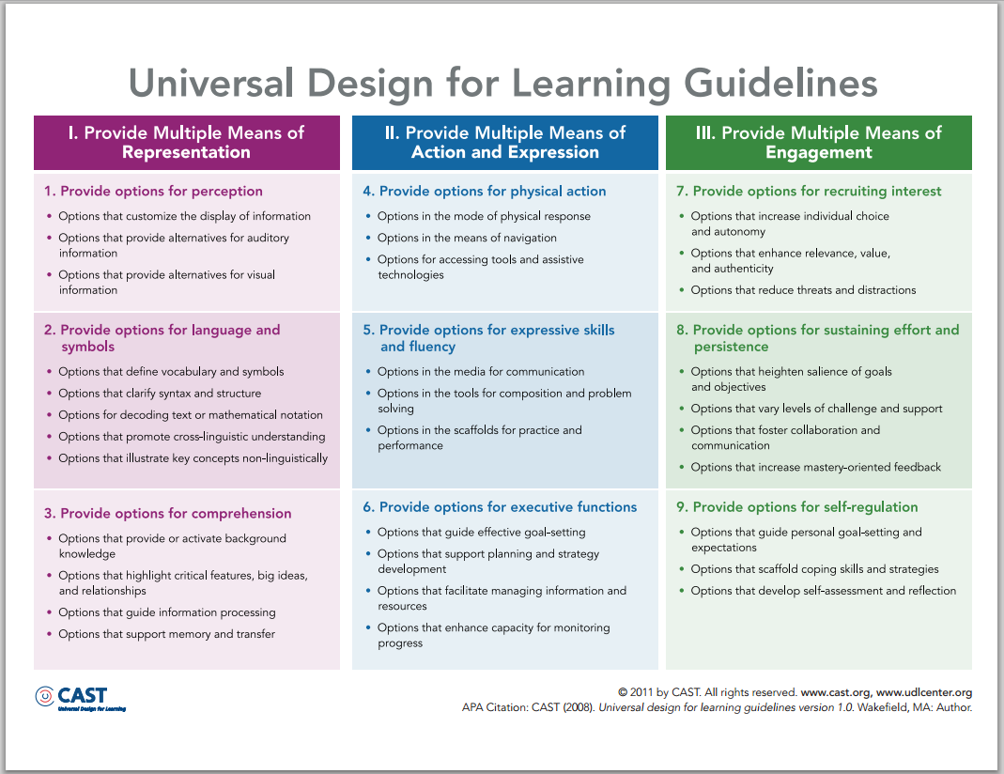

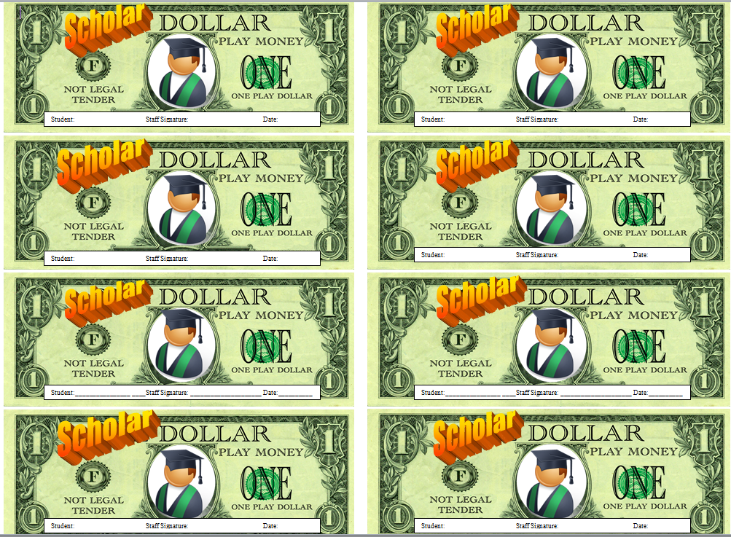

|  |  |  |  |  |  |
| --- | --- | --- | --- | --- | --- |
| BLOCK A  9:00-10:10 | MONDAY  Class; Teacher; TA; Location | TUESDAY | WEDNESDAY | THURSDAY | FRIDAY |
| Grade 12 | Own Your Voice!  Nathalie w/Abby  W-1-0043 | Research Psychology  Anna w/Bryan  W-1-0048 | Own Your Voice!  Nathalie w/Abby  W-1-0043 | Research Psychology  Anna w/Bryan  W-1-0048 | Own Your Voice!  Nathalie w/Abby  W-1-0043 |
| “ 11A | Your Money and You  Rachael w/Moi  W-1-0012 | Boston Strong  Chris w/Amelia  W-1-0044 | Your Money and You  Rachael w/Moi  W-1-0012 | Boston Strong  Chris w/Amelia  W-1-0044 | Your Money and You  Rachael w/Moi  W-1-0012 |
| “ 11B | Chemistry  Te-Ana w/Bryan  W-1-0048 | Your Money and You  Rachael w/Moi  W-1-0012 | Chemistry  Te-Ana w/Bryan  W-1-0048 | Your Money and You  Rachael w/Moi  W-1-0012 | Chemistry  Te-Ana w/Bryan  W-1-0048 |
| “ 10A | Geometry  Amanda w/Stephanie  W-1-0029 | Owning Your Voice!  Nathalie w/Abby  W-1-0043 | Geometry  Amanda w/Stephanie  W-1-0029 | Owning Your Voice!  Nathalie w/Abby  W-1-0043 | Geometry  Amanda w/Stephanie  W-1-0029 |
| “ 10B | Improv  Michelle w/Jonathan  W-1-0041 | Biology  Kate w/Hannah  W-1-0006 | Improv  Michelle w/Jonathan  W-1-0041 | Biology  Kate w/Hannah  W-1-0006 | Improv  Michelle w/Jonathan  W-1-0041 |
| “ 9A | Biology  Kristen w/Erimel – W-1-0044 | Algebra I  Amanda w/Stephanie  W-1-0029 | Biology  Kristen w/Erimel – W-1-0044 | Algebra I  Amanda w/Stephanie  W-1-0029 | Biology  Kristen w/Erimel – W-1-0044 |
| “ 9B | Environmental Science  Kate w/Hannah  W-1-0006 | Improv  Michelle w/Jonathan  W-1-0041 | Environmental Science  Kate w/Hannah  W-1-0006 | Improv  Michelle w/Jonathan  W-1-0041 | Environmental Science  Kate w/Hannah  W-1-0006 |

|  |  |  |  |  |  |
| --- | --- | --- | --- | --- | --- |
| BLOCK B  10:10-11:20 | MONDAY  Class; Teacher; TA; Location | TUESDAY | WEDNESDAY | THURSDAY | FRIDAY |
| Grade 12 | Research Psychology  Anna w/Bryan  W-1-0048 | Own Your Voice!  Nathalie w/Abby  W-1-0043 | Research Psychology  Anna w/Bryan  W-1-0048 | Own Your Voice!  Nathalie w/Abby  W-1-0043 | Research Psychology  Anna w/Bryan  W-1-0048 |
| “ 11A | Boston Strong  Chris w/Amelia  W-1-0044 | Your Money and You  Rachael w/Moi  W-1-0012 | Boston Strong  Chris w/Amelia  W-1-0044 | Your Money and You  Rachael w/Moi  W-1-0012 | Boston Strong  Chris w/Amelia  W-1-0044 |
| “ 11B | Your Money and You  Rachael w/Moi  W-1-0012 | Chemistry  Te-Ana w/Bryan  W-1-0048 | Your Money and You  Rachael w/Moi  W-1-0012 | Chemistry  Te-Ana w/Bryan  W-1-0048 | Your Money and You  Rachael w/Moi  W-1-0012 |
| “ 10A | Own Your Voice!  Nathalie w/Abby  W-1-0043 | Geometry  Amanda w/Stephanie  W-1-0029 | Own Your Voice!  Nathalie w/Abby  W-1-0043 | Geometry  Amanda w/Stephanie  W-1-0029 | Own Your Voice!  Nathalie w/Abby  W-1-0043 |
| “ 10B | Biology  Kate w/Hannah  W-1-0006 | Improv  Michelle w/Jonathan  W-1-0041 | Biology  Kate w/Hannah  W-1-0006 | Improv  Michelle w/Jonathan  W-1-0041 | Biology  Kate w/Hannah  W-1-0006 |
| “ 09A | Algebra I  Amanda w/Stephanie  W-1-0029 | Biology  Kristen w/Erimel – W-1-0044 | Algebra I  Amanda w/Stephanie  W-1-0029 | Biology  Kristen w/Erimel – W-1-0044 | Algebra I  Amanda w/Stephanie  W-1-0029 |
| “ 09B | Improv  Michelle w/Jonathan  W-1-0041 | Environmental Science  Kate w/Hannah  W-1-0006 | Improv  Michelle w/Jonathan  W-1-0041 | Environmental Science  Kate w/Hannah  W-1-0006 | Improv  Michelle w/Jonathan  W-1-0041 |

|  |  |  |  |  |  |
| --- | --- | --- | --- | --- | --- |
| BLOCK C  11:30-12:40 | MONDAY  Class; Teacher; TA; Location | TUESDAY | WEDNESDAY | THURSDAY | FRIDAY |
| Grade 12 | College Prep  Akunna  W-1-0041 | College Prep  Akunna  W-1-0041 | College Prep  Akunna w/Amelia  W-1-0041 | College Prep  Akunna  W-1-0041 | College Prep  Akunna w/Amelia  W-1-0041 |
| “ 11A | Chemistry  Te-Ana w/Bryan  W-1-0048 | Chemistry  Te-Ana w/Bryan  W-1-0048 | Chemistry  Te-Ana w/Bryan  W-1-0048 | Chemistry  Te-Ana w/Bryan  W-1-0048 | Chemistry  Te-Ana w/Bryan  W-1-0048 |
| “ 11B | Boston Strong  Chris w/Amelia  W-1-0044 | Boston Strong  Chris w/Amelia  W-1-0044 | Boston Strong  Chris  W-1-0044 | Boston Strong  Chris w/Amelia  W-1-0044 | Boston Strong  Chris  W-1-0044 |
| “ 10A | Biology  Kate w/Hannah  W-1-006 | Biology  Kate w/Hannah  W-1-006 | Biology  Kate w/Hannah  W-1-006 | Biology  Kate w/Hannah  W-1-006 | Biology  Kate w/Hannah  W-1-006 |
| “ 10B | Geometry  Amanda w/Stephanie  W-1-0029 | Geometry  Amanda w/Stephanie  W-1-0029 | Geometry  Amanda w/Stephanie  W-1-0029 | Geometry  Amanda w/Stephanie  W-1-0029 | Geometry  Amanda w/Stephanie  W-1-0029 |
| “ 9A | Own Your Voice!  Nathalie w/Abby  W-1-0043 | Own Your Voice!  Nathalie w/Abby  W-1-0043 | Own Your Voice!  Nathalie w/Abby  W-1-0043 | Own Your Voice!  Nathalie w/Abby  W-1-0043 | Own Your Voice!  Nathalie w/Abby  W-1-0043 |
| “ 9B | French  Kristen w/Erimel  W-1-0012 | French  Kristen w/Erimel  W-1-0012 | French  Kristen w/Erimel  W-1-0012 | French  Kristen w/Erimel  W-1-0012 | French  Kristen w/Erimel  W-1-0012 |

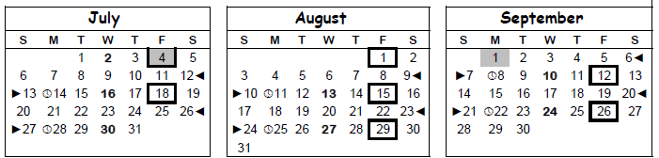

**To View Your Pay Stub online**

1. Go to UMass Boston website: <http://www.umb.edu/hr>
2. Click on the HR Direct icon to access HR Direct.
3. Your Campus User ID is your [firstname.lastname@umb.edu](mailto:firstname.lastname@umb.edu)
4. Your Password is the first (uppercase) letter in your first name + your employee ID # + the first (lowercase) letter of your last name (no space).
5. Select Boston as the campus location and hit “Enter” and you will be able to access your pay stub by clicking on the date of your check.

**Should HR issues arise, please consult directly with UMB Human Resources (3rd Floor of the Quinn Building): (617)-287-5150.**

