USP Tutoring Program – Policies and Procedures
Purpose: To support students who are struggling to meet and maintain a 3.0 GPA; to support students with rigorous coursework at school (“Honors” and “Advanced Placement” courses)
Objective: Students who are below a 3.0 must increase their cumulative GPA by .25 points by the end of the year
Resources: Academic year tutors working 1-1 with students; student required to attend 4 hours/week to earn a stipend; partner school teachers and counselors; GPA spreadsheet updated w/report cards
Supervision: Assistant Director
Timeline: In general, tutoring and advising cycles follow the BPS Report Card Schedule:
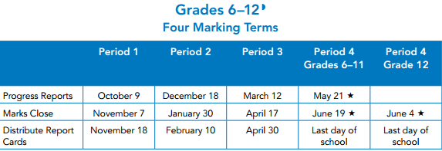
Before Fall Semester Begins (9/23)
- Report card review determines student placement
- Tutors hired, trained; binders assembled
- Student services doc updated; GPA spreadsheet completed
Throughout the Year
- 34 Weeks of 1-1 tutoring – 12 fall; 4 January; 18 spring up to final exams
- In USP classrooms, students work 1-1 with an assigned tutor to focus on subject areas most in need of improvement; group tutoring and homework occurs separately
- Students are paid the same stipend as students in class
- In portfolio: Bi-weekly progress reports, graded student work, reviewed by AD + tutors
- AD facilitates communication w/school on students’ behalf
- AD meets with students and supervises tutors
Quarterly (corresponding to BPS schedule above)
- Students bring progress reports and report cards to “progress assessment” meeting w/AD and tutor
- Status updated and action steps determined
- Advisors meet post-advising sessions to discuss report cards and student placement
Costs
  - Tutors: 40 hours of employed tutors @ $10/hr = $400/week @ 34 weeks = $13,600
  - Students: 25 students @ $25/week = $625/week @ 34 weeks = $21,250
  - Total = $34,850
Tutoring Placement:
Fall – upon previous year’s transcript review: any student with
A. 2 core subject grades of C or below
B. 1 core subject grade of D or below
Winter – upon mid-term grade review conducted by advisor: any student with
A. 2 core subject grades of C or below
B. 1 core subject grade of D or below
Election – should a student, parent, or school personnel request tutoring and qualify (have 2 or more “Honors” courses or 1 or more “AP” course)
Student will be moved from class to tutoring for the semester
Tracking Progress:
A. Through their portfolio (and under their tutor’s supervision) students keep progress logs which include
    - Time/date log
    - Bi-weekly progress reports
    - Copies of graded work
    - School progress reports, report cards
    - Action steps and reflection
B. Achievement reviewed quarterly to determine progress towards “.25 increase” objective
C. All USP student progress review by advisors 3 times per years
Accountability:
Portfolio – students will enter bi-weeklies, report cards, graded work, and action steps into portfolio binders. These are reviewed when progress reports are released.
Incomplete portfolio = Probation
Status – determined at “progress assessment” meetings when progress reports are released.
Honors = surpassing expectations – .25 growth
Good Standing = meeting expectations – on track for .25 growth
Probation = staying the same/getting worse: student must improve ½ letter grade in subjects C or below by next report card or risk dismissal; this is demonstrated in portfolio (evidence of work, bi-weeklies, attendance, etc.)
Dismissal – Director, AD, C. Counselor review file, portfolio, attendance

